## Front End Engineering - II

Project Report

Semester-IV (Batch-2022)

Portfolio Theme Builder

**Supervised By: Submitted By:**

Ms. Shagun Sharma

Kanishk Kharbanda - 2210990472 (G-10)

Lokesh Garg - 2210990544 (G-10)

Kapish Aggarwal - 2210990476 (G-10)

Jaspreet Sandhu - 2210990453 (G-10)

**Department of Computer Science and Engineering**

**Chitkara University Institute of Engineering & Technology,**

**Chitkara University, Punjab**

**Table of Content**

|  |  |  |
| --- | --- | --- |
| **S.No.** | **Section** | **Page No.** |
| 1. | Introduction | 1-3 |
| 2. | Problem Definition and Requirements | 4-5 |
| 3. | Proposed Design/Methodology | 6-7 |
| 4. | Results | 8-10 |
| 5. | References | 11 |

1. **Introduction**

This project focuses on developing a Portfolio Theme Builder, an interactive tool designed to help users create personalized portfolios. By guiding users through a series of questions, the builder allows them to effortlessly generate a custom portfolio that showcases their skills and achievements.

The technical foundation of this project includes HTML and CSS for structuring and styling the web pages, JavaScript for adding interactivity, react for building dynamic user interfaces, and Next.js for server-side rendering and enhanced performance. These technologies work together to provide a seamless and efficient user experience.

The Portfolio Theme Builder aims to be a user-friendly platform that simplifies the process of portfolio creation. This report details the design considerations, technical implementation, and challenges encountered during the development of this tool. Through this project, we demonstrate the practical application of modern web development technologies and the importance of a well-crafted portfolio in today's professional landscape.

* 1. **Background**

In today's job market, a professional portfolio is essential for showcasing skills and achievements. However, many individuals lack the technical expertise to create personalized portfolios. The Portfolio Theme Builder project addresses this need by providing an easy-to-use tool that helps users create custom portfolios through a series of guided questions.

The project utilizes HTML, CSS, JavaScript, React, and Next.js to streamline the portfolio creation process. By leveraging these technologies, the Portfolio Theme Builder makes it accessible for anyone to create a professional and personalized portfolio without needing extensive coding knowledge. This project demonstrates

the practical application of modern web development tools to solve real-world challenges.

* 1. **Objectives**

The primary objectives of Portfolio Theme Builder are:

**1. Develop an Interactive Tool**

- Create a user-friendly Portfolio Theme Builder.

**2. Utilize Modern Web Technologies**

- Implement with HTML, CSS, JavaScript, React, and Next.js.

**3. Enhance Accessibility**

- Make the tool accessible to users with varying technical expertise.

**4. Streamline Portfolio Creation**

- Simplify the process for users to showcase their skills and achievements.

**5. Provide Customization**

- Enable personalized portfolio creation reflecting unique professional identities.

* 1. **Significance**

The significance of the Portfolio Theme Builder lies in its potential to address several key challenges faced by individuals seeking to create professional portfolios. By offering an integrated and user-friendly solution, the Portfolio Theme Builder enhances user convenience and accessibility.

1. **Empowerment of Users:** It enables individuals, regardless of their technical skills, to create professional and personalized portfolios effortlessly.

**2. Time-Saving:** The tool streamlines the portfolio creation process, saving users significant time and effort compared to traditional methods.

**3. Promotion of Personal Branding:** By facilitating the creation of customized portfolios, it helps users effectively showcase their skills, achievements, and personal brand, which is crucial in today's competitive job market.

**4. Technological Integration:** Utilizing HTML, CSS, JavaScript, React, and Next.js, the Portfolio Theme Builder demonstrates the practical application and integration of modern web technologies in solving real-world problems.

**5. Enhanced User Experience:** The focus on user-friendly design and accessibility ensures a seamless experience for a wide range of users.

In summary, the Portfolio Theme Builder is not just a tool for creating portfolios; it is an innovative platform designed to simplify and enhance the process, making it an essential resource for modern professionals.

4

1. **Problem Definition and Requirements**

In today's digital era, individuals encounter numerous challenges when it comes to creating and managing their online presence through portfolios. These challenges include:

**1. Lack of Customization:** Many existing portfolio builders offer limited customization options, resulting in portfolios that fail to effectively represent the unique identity and style of their creators.

**2. Technical Complexity:** Traditional portfolio-building methods often require knowledge of coding languages such as HTML, CSS, and JavaScript, posing a barrier to entry for individuals without a technical background.

**3. Inefficient Design Workflow:** Without intuitive tools and templates, the portfolio creation process can be time-consuming and labour-intensive, detracting from the focus on content and creativity.

**4. Compatibility Issues:** Portfolios built using certain platforms may not be fully compatible across different devices and screen sizes, leading to a disjointed user experience.

To address these challenges and provide a comprehensive solution, the Portfolio Theme Builder project aims to fulfil the following requirements:

**2.1 Software Requirements:**

**1. Development Environment Languages:** HTML, CSS, JavaScript, Node.js, React

**2. Integrated Development Environments (IDEs):** Visual Studio Code (VS Code) or equivalent

**2.2 Hardware Requirements:**

**1. Development Environment Processor:** Multi-core processor (e.g., Intel Core i3 or higher)

**2. RAM:** At least 2GB to handle data structures and rendering tasks

**3. Storage:** SSD storage with ample space for datasets, development environments, and project files.

By meeting these requirements, the Portfolio Theme Builder will empower users to effortlessly create personalized portfolios that reflect their individuality and expertise, while streamlining the design process and ensuring compatibility across various devices and platforms.

1. **Proposed Design / Methodology**

The Portfolio Theme Builder project is meticulously crafted to provide users with an intuitive and efficient tool for creating personalized portfolios. The design and methodology encompass both frontend and backend considerations, ensuring a seamless user experience and robust functionality.

**3.1 Frontend Design:**

**1. React Framework:** The Portfolio Theme Builder harnesses the power of the React framework for frontend development. This choice facilitates dynamic and interactive user interfaces, thanks to React's component-based architecture. By breaking down the application into modular components, React enables easier maintenance and scalability.

**2. Responsive Design:** Ensuring accessibility across various devices is paramount. The frontend of the Portfolio Theme Builder is meticulously designed to be responsive, guaranteeing optimal performance and usability across desktops, laptops, tablets, and smartphones. This commitment to responsive design ensures a consistent experience for users, regardless of their chosen device.

**3. Intuitive User Interface:** User experience is central to the Portfolio Theme Builder's frontend design. The interface is thoughtfully crafted to be intuitive and user-friendly. Clear navigation menus, prominent calls-to-action, and intuitive controls streamline the portfolio creation process, empowering users to express their unique identities effortlessly.

**3.2 Backend Design:**

**Node.js:** For the backend infrastructure, the Portfolio Theme Builder relies on the Node.js runtime environment. Leveraging Node.js enables the handling of concurrent requests and real-time interactions, thanks to its non-blocking, event-driven architecture.

**3.3 Methodology:**

**1. Agile Development:** The Portfolio Theme Builder embraces an agile development methodology, emphasizing iterative development and continuous feedback. This approach enables rapid feature delivery and ensures responsiveness to evolving user requirements and market dynamics.

**2. User-Centered Design:** User feedback is central to the development process of the Portfolio Theme Builder. Regular solicitation of user input guides design decisions and feature prioritization, ensuring that the platform resonates with its intended audience.

**3. Continuous Integration and Deployment (CI/CD):** Automating testing, integration, and deployment processes through CI/CD practices ensures code quality and accelerates feature delivery. This streamlined approach facilitates rapid iteration and deployment of new portfolio themes and enhancements.

**4. Scalability and Performance Optimization:** The Portfolio Theme Builder is designed with scalability and performance in mind. Employing techniques such as caching, load balancing, and horizontal scaling ensures robust performance even under high user loads.

By adhering to these design principles and methodologies, the Portfolio Theme Builder aims to deliver a seamless and empowering experience for users, facilitating the creation of captivating and personalized portfolios.

**Results**

* 1. **This is the front page**

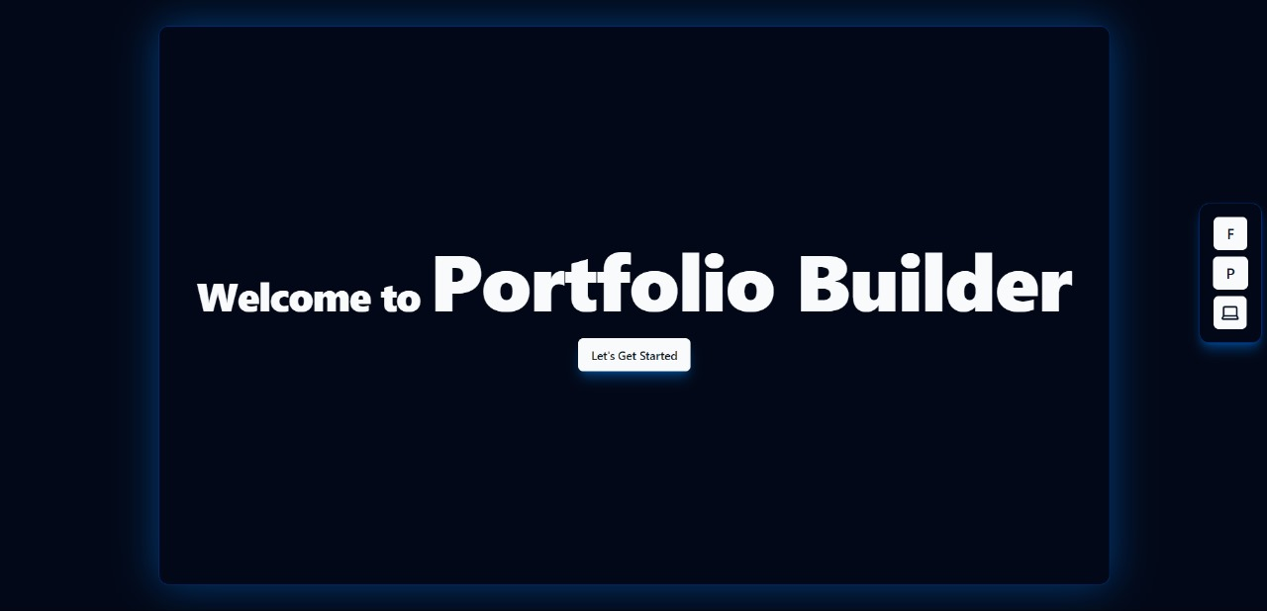

* 1. **This is the form where user inputs data**

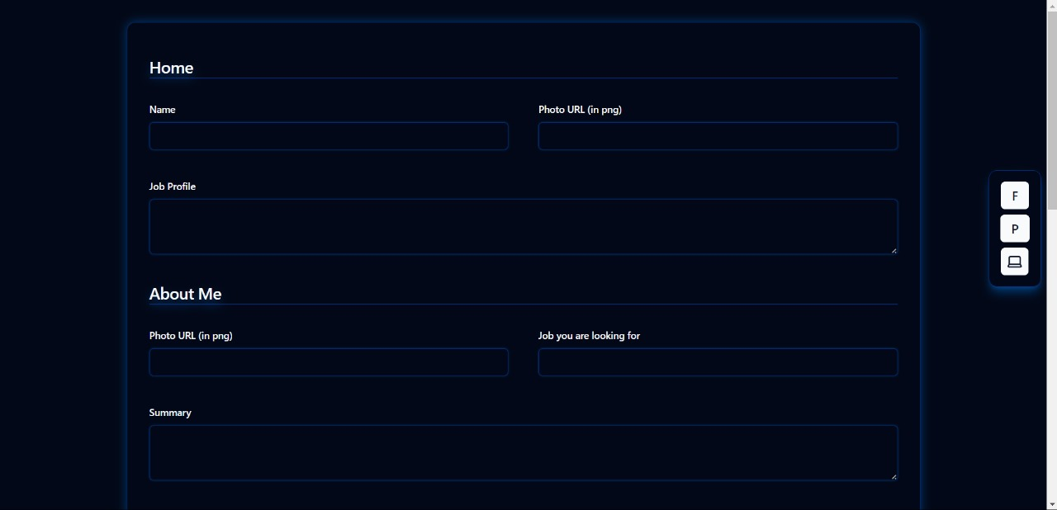

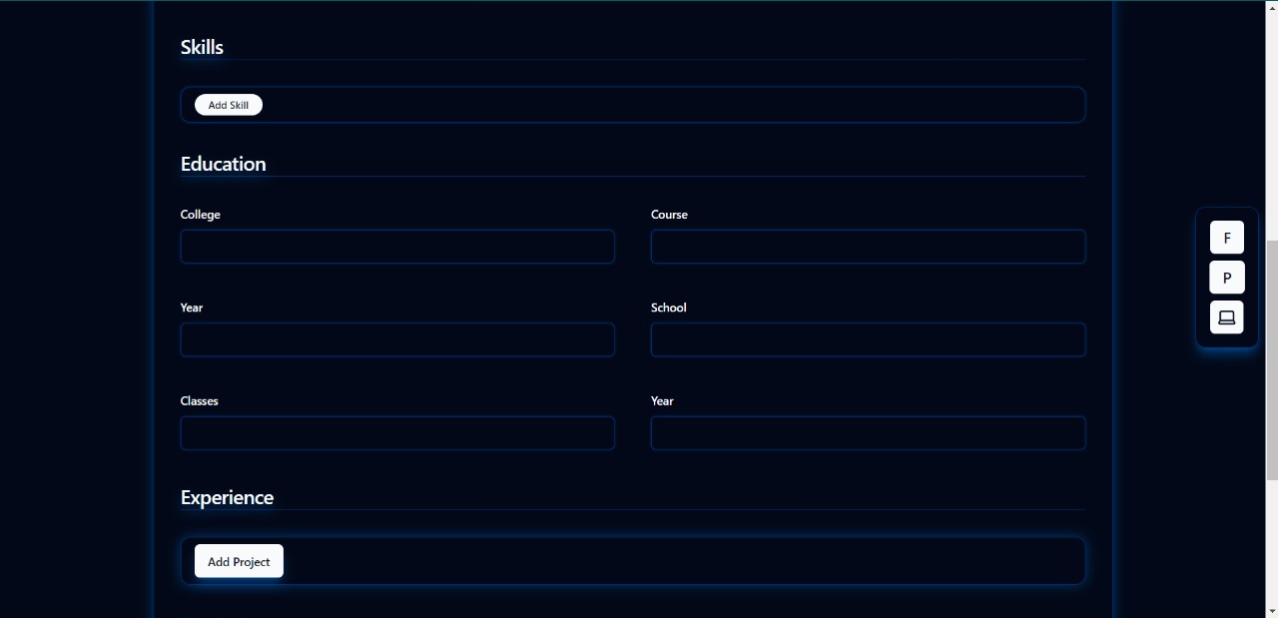

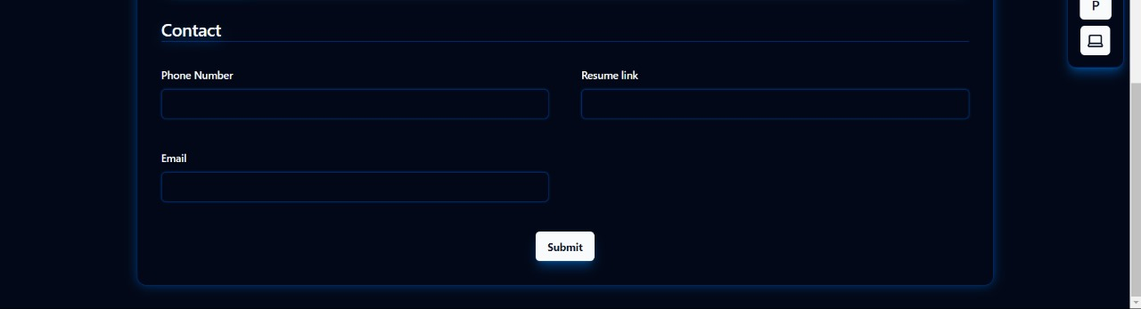

* 1. **This is the portfolio**

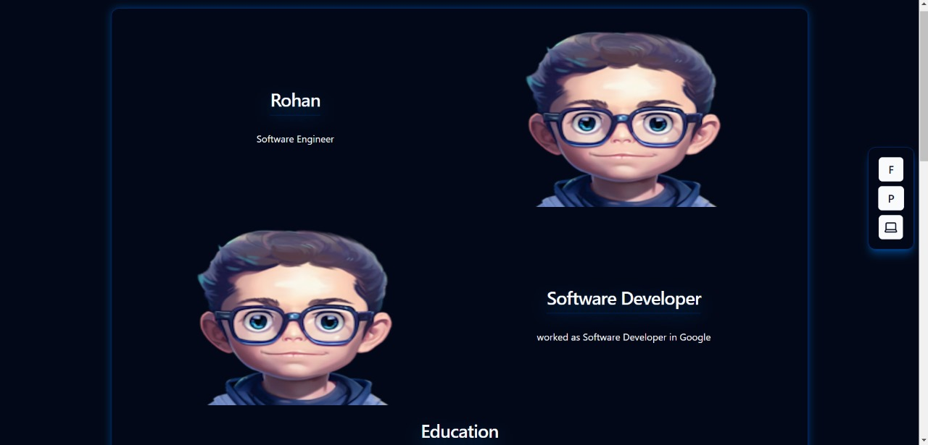

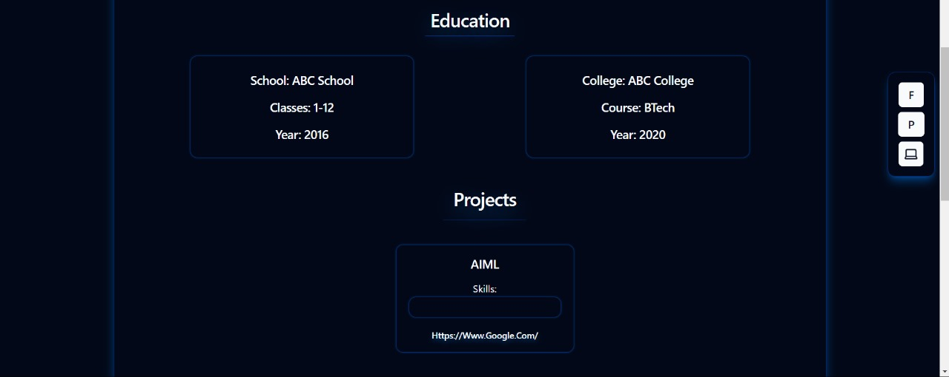

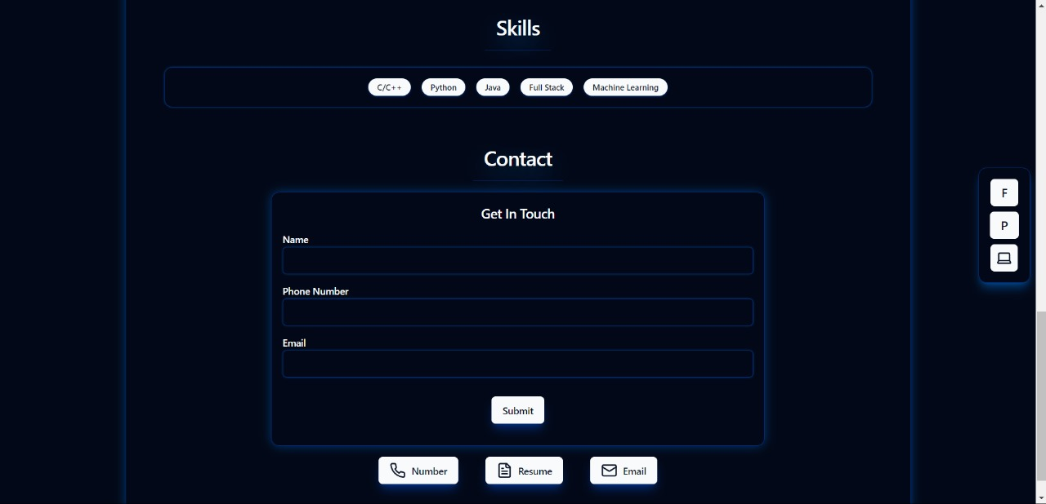

1. **References**
   * 1. geeksforgeeks.com
     2. W3schools.com
     3. Codepen.com
     4. React.org
     5. Devdocs.io
     6. Freecodecamp.org
     7. MDN web-docs